-**A PROJECT REPORT**

**on**

**“NFT Marketplace”**

**Submitted to**

**KIIT Deemed to be University**

**In Partial Fulfillment of the Requirement for the Award of**

**BACHELOR’S DEGREE IN**

**COMPUTER SCIENCE AND ENGINEERING**

**BY**

**Aditya Pandey**

**Shivam Atulya**

**Shreyansh Agarwal**

**Ankush Roy Chowdhury**

**Gaurav Kumar Singh**

1905223

1905247

1905277

1905306

1905610

**UNDER THE GUIDANCE OF**

**KUNAL ANAND**



**SCHOOL OF COMPUTER ENGINEERING**

**KALINGA INSTITUTE OF INDUSTRIAL TECHNOLOGY**

**BHUBANESWAR, ODISHA - 751024**

**May 2023**

A PROJECT REPORT

on

“NFT Marketplace”

Submitted to

KIIT Deemed to be University

In Partial Fulfillment of the Requirement for the Award of

BACHELOR’S DEGREE IN

COMPUTER SCIENCE AND ENGINEERING

BY

Aditya Pandey

Shivam Atulya

Shreyansh Agarwal

Ankush Roy Chowdhury

Gaurav Kumar Singh

1905223

1905247

1905277

1905306

1905610

UNDER THE GUIDANCE OF

KUNAL ANAND



SCHOOL OF COMPUTER ENGINEERING

KALINGA INSTITUTE OF INDUSTRIAL TECHNOLOGY

BHUBANESWAR, ODISHA -751024

May 2023

KIIT Deemed to be University

School of Computer Engineering

Bhubaneswar, ODISHA 751024



CERTIFICATE

This is certify that the project entitled

“NFT Marketplace “

submitted by

Aditya Pandey

Shivam Atulya

Shreyansh Agarwal

Ankush Roy Chowdhury

Gaurav Kumar Singh

1905223

1905247

1905277

1905306

1905610

is a record of bonafide work carried out by them, in the partial fulfilment of the requirement for the award of Degree of Bachelor of Engineering (Computer Science & Engineering) at KIIT Deemed to be university, Bhubaneswar. This work is done during year 2022-2023, under our guidance.

Date: 03 /05 /2023

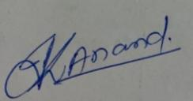

(Kunal Anand)

Project Guide

**Acknowledgements**

We are profoundly grateful to **KUNAL ANAND** of **School of Computer Science** for his expert guidance and continuous encouragement throughout to see that this project meets its target since its commencement to its completion.

Aditya Pandey

Shivam Atulya

Shreyansh Agarwal

Ankush Roy Chowdhury

Gaurav Kumar Singh

**ABSTRACT**

An NFT (Non-Fungible Token) Marketplace is a platform where users can buy, sell, and trade unique digital assets that are represented as NFTs. These digital assets can include art, collectibles, in-game items, domain names, and more. Each NFT is unique and cannot be replaced or exchanged on a one-to-one basis with another NFT. The need for an NFT Marketplace arises from the increasing demand and popularity of non-fungible tokens (NFTs) in various sectors such as art, gaming, collectibles, and more.

NFT Marketplaces play a crucial role in the growing ecosystem of non-fungible tokens by providing a platform for creators to monetize their work, collectors to access unique digital assets, and fostering a global community around digital art and collectibles.

**Keywords** : NFT (Non-Fungible Token), Digital Ownership, Digital Assets, Collectibles, Marketplace.



Contents

| 1 | Introduction | | | | | 7 |
| --- | --- | --- | --- | --- | --- | --- |
| 2 | Basic Concepts | | | | | 8 |
| 3 | Problem Statement / Requirement Specifications | | | | | 10 |
|  | 3.1 | Project Planning | | | | 10 |
|  | 3.2 | Project Analysis (SRS) | | | | 11 |
|  |  | 3.2.1 | Facial Expression Recognition | | | 11 |
|  |  | 3.2.2 | Home Page on Display | | | 11 |
|  | 3.3 | System Design | | | | 12 |
|  |  | 3.3.1 | | Design Constraints | | 12 |
|  |  | 3.3.2 | | System Architecture (UML) / Block Diagram … | | 13 |
|  |  |  | | 3.3.2.1 | Activity diagram | 13 |
|  |  |  | | 3.3.2.2 | Class Diagram | 14 |
|  |  |  | | 3.3.2.3 | User-Class Diagram | 15 |
|  |  |  | | 3.3.2.4 | Stats-Charts Diagram | 16 |
| 4 | Implementation | | | | | 17 |
|  | 4.1 | Methodology / Proposal | | | | 18 |
|  |  | 4.1.1 | | Machine Learning using Python | | 18 |
|  |  |  | | 4.1.1.1 | Data Collection | 18 |
|  |  |  | | 4.1.1.2 | Data Pre-processing | 18 |
|  |  |  | | 4.1.1.3 | Exploratory Data Analysis | 20 |
|  |  | 4.1.2 | | Model Application | | 21 |
|  |  | 4.1.3 | | Web Development | | 22 |
|  |  |  | | 4.1.3.1 | Form Creation & Validation | 22 |
|  |  |  | | 4.1.3.2 | Database entry | 22 |
|  |  |  | | 4.1.3.3 | User-page creation | 23 |
| 5 | Standard Adopted | | | | | 24 |
|  | 5.1 | Design Standards | | | | 24 |
|  | 5.2 | Coding Standards | | | | 24 |
| 6 | Conclusion and Future Scope | | | | | 25 |
|  | 6.1 | Conclusion | | | | 25 |
|  | 6.2 | Future Scope | | | | 25 |
| References | | | | | | 26 |
| Individual Contribution Reports | | | | | |  |
| Plagiarism Report | | | | | |  |

Chapter 1

Introduction

NFT Marketplace project aims to create a digital platform that enables users to buy, sell, and trade non-fungible tokens (NFTs). NFTs are unique digital assets that represent ownership of various items such as artwork, collectibles, in-game items, domain names, and more. Each NFT is distinct and cannot be exchanged on a one-to-one basis with another NFT.

The primary goal of the project is to develop a user-friendly platform that allows seamless interaction between creators who mint new NFTs and collectors who purchase or trade them. Blockchain is the underlying technology that enables NFTs to exist. It's a decentralized, distributed ledger that records transactions across multiple computers. This ensures the security and immutability of data stored on the blockchain. In the case of NFTs, blockchain technology allows for verifying ownership and provenance of digital assets.

Marketplaces are platforms where users can buy, sell, or trade NFTs. Some popular NFT marketplaces include OpenSea, Rarible, and SuperRare. These platforms allow creators to mint (create) NFTs by uploading their digital assets and attaching metadata to them. Buyers can then purchase these tokens using cryptocurrencies like Ether (ETH).

The need for an NFT Marketplace project arises due to the growing interest and demand for non-fungible tokens (NFTs) in various sectors, such as art, gaming, collectibles, and more. Here are some reasons why NFT Marketplaces are essential:

1. Digital Ownership: NFT Marketplaces provide a platform for creators and collectors to establish verifiable digital ownership of unique assets. Through blockchain technology, NFTs can prove the authenticity and provenance of digital items, ensuring that buyers are purchasing genuine assets.
2. Monetization for Creators: Artists and content creators can monetize their work by minting NFTs and selling them on the marketplace. This opens up new revenue streams for creators who might not have had access to traditional methods of selling their work.
3. Interoperability & Cross-Platform Support: Many NFT Marketplaces support cross-platform compatibility which means that users can buy, sell or trade NFTs across multiple platforms. This enhances liquidity and accessibility for both creators and collectors.
4. Secure Transactions: The use of blockchain technology ensures secure transactions without intermediaries or third-party involvement. Smart contracts automate the process of buying, selling or trading NFTs while maintaining transparency and trust between all parties involved.
5. Community Building: NFT Marketplaces often foster a sense of community among creators and collectors. Users can interact with each other, share their interests, and discover new artists or collectibles, further promoting the growth and adoption of NFTs.

Chapter 2

Basic Concepts

2.1 Web 3.0

Web3, also known as Web 3.0 or the decentralized web, is a vision for the next generation of the internet that aims to create a more decentralized, secure, and user-centric ecosystem. In contrast to the current web (Web 2.0), which relies heavily on centralized platforms and intermediaries, Web3 seeks to empower users by giving them more control over their data, assets, and online interactions.The basic concepts of Wb 3.0 are :

1. Decentralization: The primary goal of Web3 is to reduce reliance on centralized platforms and intermediaries by distributing data and services across multiple nodes in a network. This can increase security, privacy, and resistance to censorship.
2. Blockchain Technology: Blockchain serves as the backbone for many Web3 applications by providing a decentralized ledger that records transactions in a secure and transparent manner. It enables trustless interactions between parties who may not know or trust each other.
3. Smart Contracts: Smart contracts are self-executing agreements with terms directly written into code that runs on blockchain networks like Ethereum. They automate processes and enable complex logic to be executed without relying on third-party intermediaries.
4. Cryptocurrencies & Tokens: Cryptocurrencies like Bitcoin (BTC) or Ether (ETH) facilitate peer-to-peer transactions within decentralized networks. Tokens built on top of blockchain platforms can represent various digital assets or utilities within specific applications.
5. Decentralized Applications (dApps): dApps are applications built on top of blockchain networks that leverage smart contracts and decentralized infrastructure to provide services without central points of control.
6. Identity & Privacy: Web3 aims to give users more control over their digital identities by allowing them to own and manage their data. Decentralized identity solutions can help users authenticate themselves without relying on centralized services, enhancing privacy and security.
7. Interoperability: Web3 envisions a more interconnected ecosystem where different blockchain networks and applications can communicate with each other seamlessly, enabling cross-platform transactions and data sharing.

2.2 NFT

NFT stands for Non-Fungible Token. It represents a unique digital asset on a blockchain, which cannot be replicated or replaced with another token. NFTs have distinct properties and value, making them non-interchangeable, unlike cryptocurrencies like Bitcoin or Ethereum. It’s generally built using the same kind of programming as cryptocurrency but that’s where the similarity ends.

Physical money and cryptocurrencies are “fungible,” meaning they can be traded or exchanged for one another. They’re also equal in value—one dollar is always worth another dollar; one Bitcoin is always equal to another Bitcoin. Crypto’s fungibility makes it a trusted means of conducting transactions on the blockchain.

NFTs are different. Each has a digital signature that makes it impossible for NFTs to be exchanged for or equal to one another (hence, non-fungible).NFTs exist on a blockchain, which is a distributed public ledger that records transactions.

NFTs can have only one owner at a time. NFTs’ unique data makes it easy to verify their ownership and transfer tokens between owners. The owner or creator can also store specific information inside them.

2.3 Blockchain

Blockchain is a decentralized, distributed ledger technology that records transactions across multiple computers in a secure and tamper-proof manner. It consists of a chain of blocks, where each block contains a set of transactions. Once a block is added to the chain, it cannot be altered, ensuring the immutability of data stored on the blockchain.

Here are some key features and aspects of blockchain technology:

1. Decentralization: Blockchain operates without a central authority, distributing control across multiple nodes (computers) in the network. This eliminates single points of failure and reduces the risk of corruption or manipulation.
2. Transparency: All transactions on the blockchain are visible to every participant in the network, promoting transparency and trust among users.
3. Immutability: Once a transaction is recorded on the blockchain and validated by consensus, it cannot be altered or removed. This ensures that data stored on the blockchain is permanent and tamper-proof.
4. Security: Blockchain uses cryptographic techniques like public-key cryptography to secure transactions and user identities. Additionally, consensus mechanisms help protect against malicious actors attempting to manipulate or attack the network.

In conclusion, blockchain is a transformative technology that has the potential to revolutionize various industries by providing a secure, transparent, and decentralized infrastructure for recording transactions and managing data.

Chapter 3

Problem Statement / Requirement Specifications

**Problem Statement**: Design and develop an NFT marketplace platform that allows creators to mint, showcase, and sell their unique digital assets, while providing collectors with a secure and user-friendly environment to discover, purchase, and trade NFTs.

3.1 Project Planning

The project plan for the NFT marketplace involves the development of a secure and user-friendly platform for buying, selling and trading NFTs. The plan includes the development of a smart contract for managing NFTs, a web application for interacting with the platform using Solidity, and the use of the Web3.js library for communicating with the Ethereum network - Goerli Network. The project will be executed in four milestones, including the creation and deployment of the smart contract, the front-end UI using NEXT.js, the back-end interface for buying and selling NFTs, and the testing of the full application using Mocha and Chai. Risks such as technical issues, security vulnerabilities, and lack of user adoption will be mitigated through thorough testing, adherence to best practices, and market research. The successful completion of this project will provide a more accessible and transparent market for NFTs, enabling greater participation and fostering innovation among creators and collectors.

3.2 Project Analysis

3.2.1 NFT Marketplace

Before embarking on the development of an NFT marketplace, it is essential to conduct a thorough project analysis. This involves identifying the market demand, competition, and technical feasibility of the project.

Market demand analysis will involve researching the current state of the NFT market, including the growth trajectory and potential future developments. It is also important to determine the target audience for the marketplace, such as creators, collectors, investors, or enthusiasts. Understanding the users' needs and preferences will be crucial in designing a platform that meets their requirements.

Competition analysis involves identifying existing platforms that offer similar services and assessing their strengths and weaknesses. This information will enable the development of a platform that offers unique value propositions and sets itself apart from the competition. Additionally, identifying potential partnerships with existing platforms or marketplaces can help to expand the reach of the NFT marketplace.

Technical feasibility analysis involves assessing the technological requirements of the project and identifying any potential challenges or limitations. This includes researching the required infrastructure for hosting the platform, the development of smart contracts for managing NFTs, and the integration of blockchain technology. It is also important to consider the scalability and security requirements of the platform, ensuring that it can handle large volumes of traffic and protect user data and assets.

By conducting a thorough project analysis, the development team can ensure that the NFT marketplace meets the market demand, differentiates itself from the competition, and can be successfully developed and deployed.

3.3.2 System Architecture (UML) / Block Diagram

3.3.2.1 Activity diagram



3.3.2.2 Class Diagram

3.3.2.3 User-Class Diagram



3.3.2.4 Stats Chart Diagram

Chapter 4

Implementation

4.1 Methodology

4.1.1 Backend

4.1.1 Frontend

Implementing the frontend for an NFT marketplace requires a set of web development tools and technologies. Here are essential components for building the frontend of an NFT marketplace:

1. We desinged the user interface (UI) of the NFT marketplace using a design tool like Figma, Adobe XD, or Sketch. This includes creating wireframes and high-fidelity designs for the various pages and components of the marketplace.
2. Created the HTML templates for various pages of the marketplace using a text editor or an integrated development environment (IDE) Visual Studio Code
3. Style the HTML templates using Tailwind CSS, a utility-first CSS framework that makes it easy to create custom designs without writing custom CSS.
4. Use NextJS, a React-based web framework, to create a server-rendered web application that integrates with the Solidity smart contracts that power the NFT marketplace. This involves setting up the NextJS project and creating pages that fetch and display data from the smart contracts.
5. Connected our frontend to the Solidity smart contracts using a Web3 library like ethers.js. This involves writing JavaScript code to interact with the smart contracts and handle user interactions on the frontend.
6. We then tested the frontend implementation using a local blockchain network like Goerli Network to ensure that everything works as expected.

.

4.1.3 Testing

After project work is compete, it must have some verification criterion so that we can decide whether the project satisfactorily completed or not. This is called Testing or verification. For example, in software development, some test case must be included and used to verify the outcome of the project.

| Test | Test Case Title | Test Condition | System Behavior | Expected Result |
| --- | --- | --- | --- | --- |
| ID |  |  |  |  |
|  |  |  |  |  |
| T01 | Deployment of NFT | create and deploy a new nftmarketplace | should create a new empty marketplace | passed successfully |
|  |  |  |  |  |
| T02 | Mint and list a new NFT token | 1.price of new nft token should be greater than 0.  2.listing price of nft token should be correct.  3.Should create a new nft token and assign a correct token  token Uniform Resource Identifier    4. A new NFT market item should be created | 1.Should revert if price is zero  Should revert if listing price is not correct  2.Should revert if listing price is not correct  3. Should create an NFT with the correct owner and tokenURI  4. Should emit MarketItemCreated after successfully listing of NFT. | passed successfully  passed successfully  passed successfully  passed successfully |
|  |  |  |  |  |
| T03 | Execute sale of a marketplace item | 1.should have correct asking price in order to purchase.  2.test the buying of new token and transfer the ownership to buyer | 1.Should revert if auction price is not correct.  2. Buy a new token and check token owner address. | passed successfully  passed successfully |
|  |  |  |  |  |
| T04 | Resale of a marketplace item | 11. Reselling should be performed by owner only and upon proving correct listing price.  2.Buying a new nft token and then reselling it | 1.Should revert if the token owner or listing price is not correct  2.Buy a new token and then resell it | passed successfully  passed successfully |
| T05 | Fetch marketplace items | 1.list the correct number of unsold items  2.list the correct number of sold nfts  3.display correct number of items listed by user | 1.Should fetch the correct number of unsold items  2.Should fetch correct number of items that a user has purchased  3.Should fetch correct number of items listed by a user | passed successfully  passed successfully  passed successfully |
| T06 | Cancel a Marketplace listing | 1.cancel the nft listing and also correct the number of listings | Should cancel and return the correct number of listings | passed successfully |



Chapter 5

Standards Adopted

5.1 Design Standards

Design standards are essential for creating a consistent, user-friendly, and visually appealing NFT marketplace. Here are some key design standards to apply during the development of your NFT marketplace project:

1. Consistent UI Components: Use a consistent design language for all UI components such as buttons, input fields, navigation menus, and typography. This can be achieved by using a design system or a UI framework like NextJS.
2. Responsive Design: Ensure that your platform is mobile-friendly and adapts to various screen sizes and devices for an optimal user experience. Use responsive design techniques like media queries, fluid grids, and flexible images.
3. Clear Navigation: Design an intuitive navigation structure that allows users to easily find their way around the platform.
4. Visual Hierarchy: Organize content on each page using visual hierarchy principles like size, color, contrast, and spacing to guide users' attention towards important elements.
5. Whitespace: Utilize whitespace effectively to create a clean layout that improves readability and reduces visual clutter.
6. Color Scheme: Choose a harmonious color scheme that complements your brand identity while maintaining readability and accessibility.
7. Error Handling: Provide helpful error messages and guidance when users encounter issues or need assistance with certain tasks.

5.2 Coding Standards

Applying coding standards during the NFT marketplace project ensures that your code is clean, maintainable, and consistent across the entire development team. Here are some key coding standards to follow:

1. Naming Conventions: Use clear and descriptive names for variables, functions, classes, and files. Follow language-specific naming conventions like camelCase for JavaScript.
2. Code Formatting: Adhere to consistent code formatting rules such as indentation, line length, and whitespace usage. You can use tools like Prettier (for JavaScript) to automatically format your code.
3. Comments & Documentation: Write comments to explain complex or non-obvious parts of your code. Provide documentation for functions and classes that describe their purpose, inputs, outputs, and any side effects.
4. Modular & Reusable Code: Organize your code into modular components (e.g., functions or classes) that can be easily reused and tested independently.
5. DRY Principle: Follow the "Don't Repeat Yourself" principle by avoiding duplicate code and extracting shared functionality into separate modules or functions.
6. Error Handling: Implement proper error handling using try-catch blocks or other language-specific constructs to ensure graceful handling of unexpected situations.
7. Code Review & Collaboration: Conduct regular code reviews with your team members to identify potential issues, improve code quality, and share knowledge among the team.
8. Version Control: Use a version control system like Git to track changes in your codebase and collaborate effectively with other developers.
9. Testing: Write unit tests for critical parts of your application.
10. Dependency Management: Keep track of third-party libraries and packages used in your project, ensuring that they are up-to-date and compatible with your codebase.

Chapter 6

6.1 Conclusion

Non-Fungible Token (NFT) is a new technology that is gaining traction in the blockchain market. Through this project we can look at cutting-edge NFT solutions that could reshape the digital/virtual asset market in the future.We can see the analysis and results of the NFT Marketplace on our UI interface,also we gained the knowledge regarding the different testnets that can be used for running and deploying central contract without being dependent on real cryptocurrencies.

NFT marketplace is a powerful platform that enables creators to mint, showcase, and sell their unique digital assets while providing collectors with a secure and user-friendly environment to discover, purchase, and trade NFTs. By leveraging blockchain technology, NFT marketplaces ensure the authenticity, provenance, and ownership of digital assets.

Developing an NFT marketplace requires careful planning, design, implementation, and adherence to coding standards. It's essential to focus on providing a seamless user experience by incorporating responsive design principles, clear navigation structures, and visually appealing interfaces. Additionally, ensuring the security of transactions and user data is of utmost importance.

6.2 Future Scope

The future scope of this project will be testing this project in different test networks such as Ethereum mainnet,Sepolia test network etc. Currently we have used goerli testnet ethers for testing smart contracts and deploying them,in future we can integrate them with real and different types of cryptocurrencies which are well within the guidelines prescribed by the government.Currently the project is running on localhost,in future we can deploy it on netlify,vercel or render.

The future scope for NFT marketplace projects is rich with possibilities for innovation and growth. By staying informed about emerging trends and technologies in the digital asset space, you can position your NFT marketplace project for long-term success.



References

[1] Solidity Documentation: https://docs.soliditylang.org/en/v0.8.19/

[2] HardHat Documentation: https://hardhat.org/doc

[3] NextJS Documentation: https://nextjs.org/docs/getting-started

[4] Metamask Documentation: https://docs.metamask.io/wallet/

[5] Mocha Documentation: <https://mochajs.org/>

[6] Chai Documentation: https://www.chaijs.com/

**NFT Marketplace**

ADITYA PANDEY

1905223

**Abstract:** The NFT marketplace project aims to develop a platform for creators to mint, showcase, and sell unique digital assets while providing collectors a secure and user-friendly environment for discovering, purchasing, and trading non-fungible tokens (NFTs). Key features include user authentication, minting NFTs, browsing and discovery options, secure transactions using smart contracts, auctions, royalties, and personalized user dashboards.

**Individual contribution:** I have contributed by installing Package Configuration environment and developed the backend of the project. Some of the work contributed are Cancel market listing and resell Market Listing features in the project.

**Individual contribution to project report preparation:** I have contributed in making the UML diagram for the report. I gave my contribution in chapters 2, 3, 4, 5 & 6..

**Individual contribution for project presentation and demonstration:** The presentation was built in unison in a group and everyone contributed equally in this part. I was responsible for demonstration of backend working of the project.

Full Signature of Supervisor: Full signature of the student:

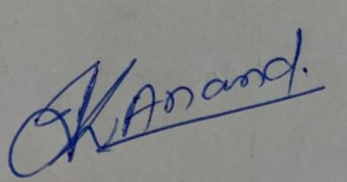 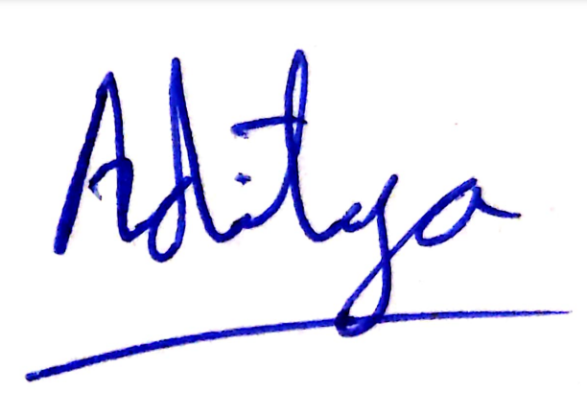

**NFT Marketplace**

SHIVAM ATULYA

1905247

**Abstract:** The NFT marketplace project aims to develop a platform for creators to mint, showcase, and sell unique digital assets while providing collectors a secure and user-friendly environment for discovering, purchasing, and trading non-fungible tokens (NFTs). Key features include user authentication, minting NFTs, browsing and discovery options, secure transactions using smart contracts, auctions, royalties, and personalized user dashboards.

**Individual contribution and findings:** I contributed to the frontend part of the project in which I used NextJs,HTML and CSS(mainly tailwind CSS) . Designing of the website was also my part for the same. With help of my team member Shreyansh , we created and integrated the project with the backend .

**Individual contribution to project report preparation:**I have contributed in making the UML diagram for the report. I gave my contribution in chapters 3,4,5 for the project for parts named as project analysis, testing, result analysis and standards adopted.

**Individual contribution for project presentation and demonstration:** The presentation was built in unison in a group and everyone contributed equally in this part. I made the data perfect for training the model and executing further processes on it.

Full Signature of Supervisor: Full signature of the student:

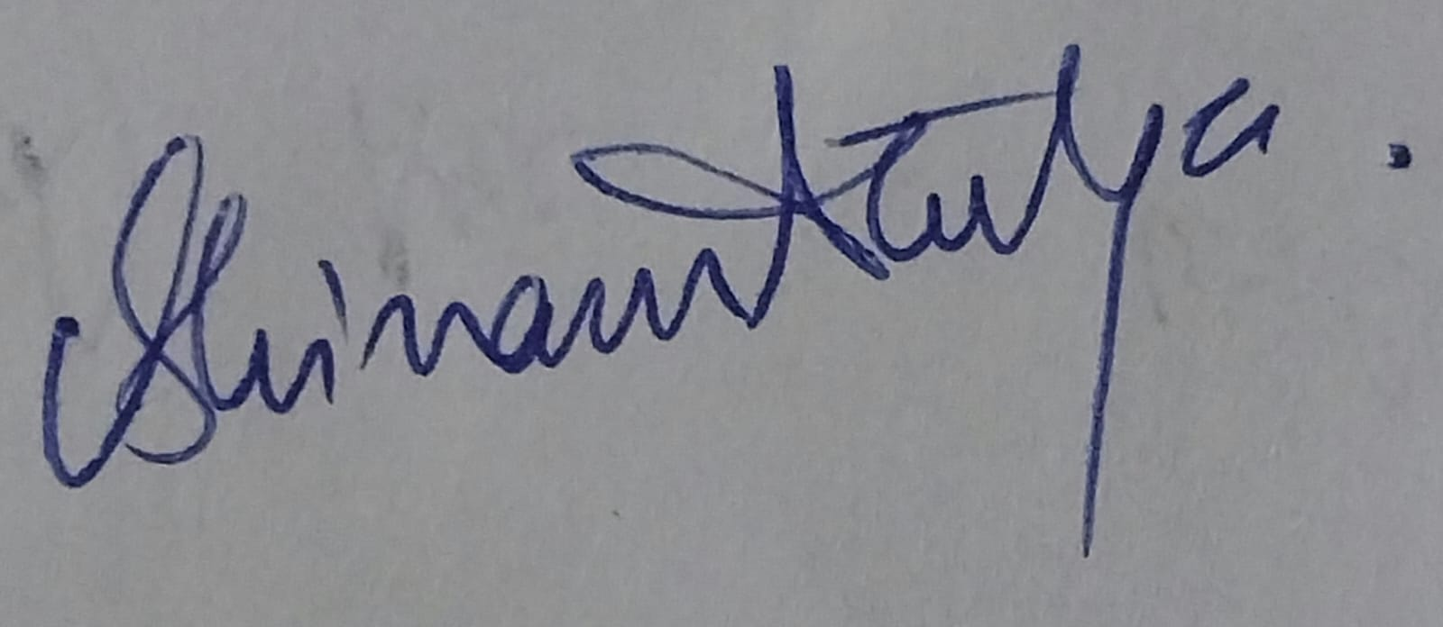



**NFT Marketplace**

SHREYANSH AGARWAL

1905277

**Abstract:** The NFT marketplace project aims to develop a platform for creators to mint, showcase, and sell unique digital assets while providing collectors a secure and user-friendly environment for discovering, purchasing, and trading non-fungible tokens (NFTs). Key features include user authentication, minting NFTs, browsing and discovery options, secure transactions using smart contracts, auctions, royalties, and personalized user dashboards.

**Individual contribution and findings:** I contributed towards the front-end part of the project. The user interface for the project was built by me along with my teammate Shivam. I have mainly used front end technologies such as next.js,html and css (mainly tailwind). I was responsible for collecting goerli testnet ether by data mining which would help us in running and deploying central contracts. The whole project was run on localhost by me and a video recording too was recorded for the same.

**Individual contribution to project report preparation:** I have contributed towards chapter 3,4,6 of the project report which included project planning,project analysis,project implementation,conclusion and future scope.

**Individual contribution for project presentation and demonstration:** The presentation was built in unison in a group and everyone contributed equally in this part. I also contributed in styling the presentation,preparing the front-end slides and presenting the same.

Full Signature of Supervisor: Full signature of the student:

 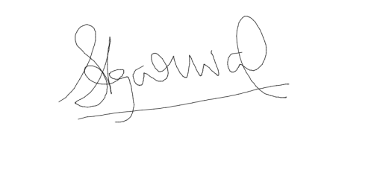

**NFT Marketplace**

GAURAV KUMAR SINGH

1905610

**Abstract:** The NFT marketplace project aims to develop a platform for creators to mint, showcase, and sell unique digital assets while providing collectors a secure and user-friendly environment for discovering, purchasing, and trading non-fungible tokens (NFTs). Key features include user authentication, minting NFTs, browsing and discovery options, secure transactions using smart contracts, auctions, royalties, and personalized user dashboards.

**Individual contribution:** I have contributed by Metamask Wallet Configuration and developed the backend of the project. Some of the work contributed are creating sale of marketplace item and transfer of ownership of items and funds.

**Individual contribution to project report preparation:** I have contributed towards chapter 1,2,3 of the project report which included project planning,project analysis,project implementation,conclusion and future scope.

**Individual contribution for project presentation and demonstration:** The presentation was built in unison in a group and everyone contributed equally in this part. I demonstrated the backend of the system.

Full Signature of Supervisor: Full signature of the student:

 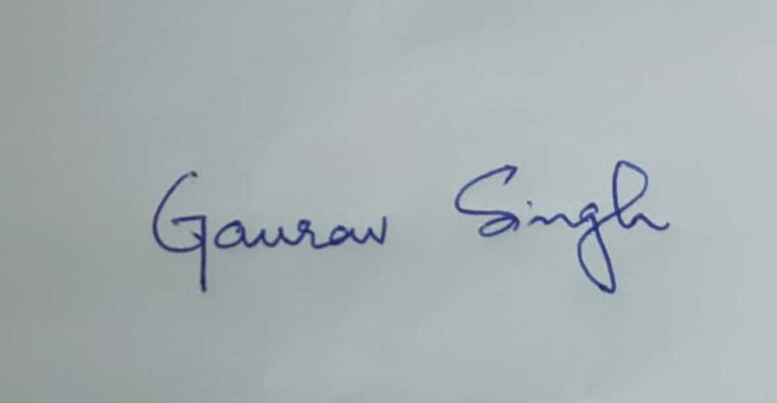

**NFT Marketplace**

Ankush Roy Chowdhury

1905306

**Abstract:** The NFT marketplace project aims to develop a platform for creators to mint, showcase, and sell unique digital assets while providing collectors a secure and user-friendly environment for discovering, purchasing, and trading non-fungible tokens (NFTs). Key features include user authentication, minting NFTs, browsing and discovery options, secure transactions using smart contracts, auctions, royalties, and personalized user dashboards.

**Individual contribution and findings:** I contributed towards the testing part of the project.

**Individual contribution to project report preparation:** I have contributed towards chapter 4,5,6 of the project report which included project planning,project analysis,project implementation,conclusion and future scope.

**Individual contribution for project presentation and demonstration:** The presentation was built in unison in a group and everyone contributed equally in this part. I also contributed in styling the presentation,preparing the front-end slides and giving final finishing to it.

Full Signature of Supervisor: Full signature of the student:



TURNITIN PLAGIARISM REPORT

